APP DEV AND EMERGING TECHs

Jericho Bruce Rivero | BSIT

Activity 2

1. Write a C Language system that will display the below sentence, filled with your corresponding details. Note that you will declare and call variables.

“Hi! My name is __________. I am ______ years old and I live in _________________ City.”

Put your source code and screenshot of the running program below.

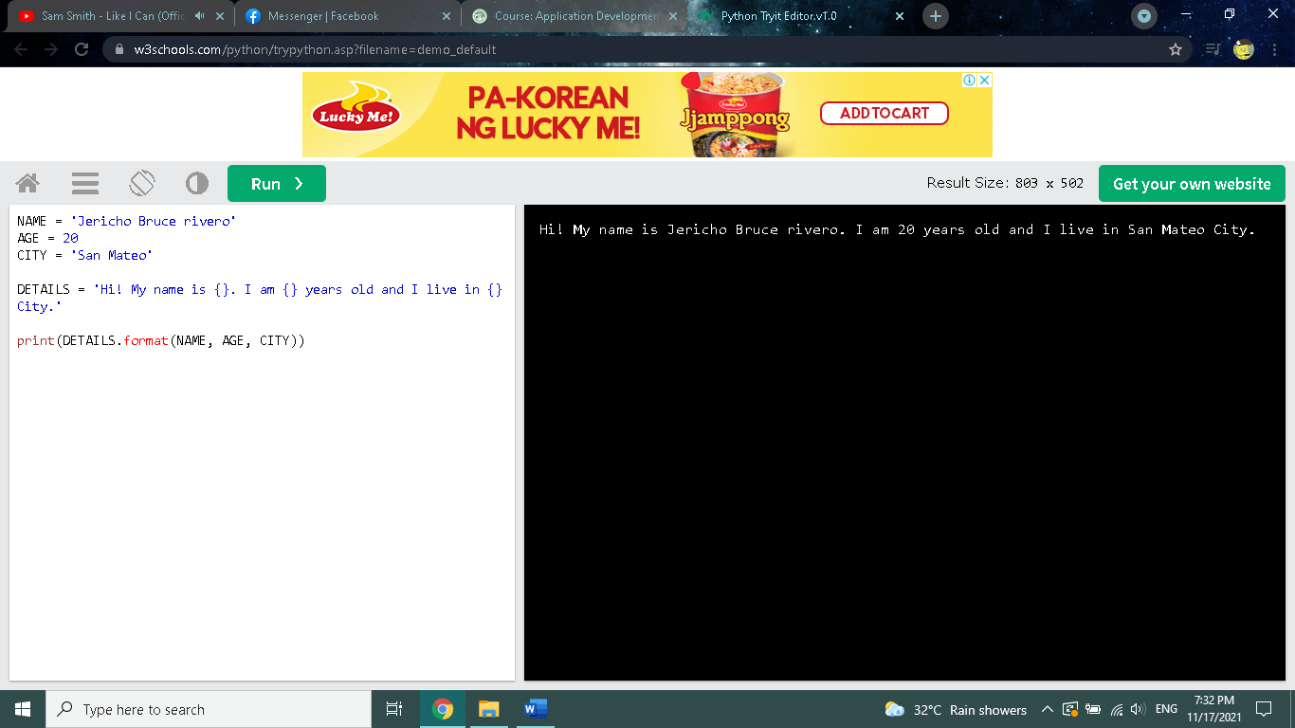



NAME = 'Jericho Bruce rivero'

AGE = '20'

CITY = 'San Mateo'

DETAILS = 'Hi! My name is {}. I am {} years old and I live in {} City.'

print(DETAILS.format(NAME, AGE, CITY))